Ex.No: 18

Date:

**HIGH LEVEL LANGUAGE EXTENSION WITH CURSORS**

**Aim:**

To implement Cursors using program in MySQL.

**Description:**

**Cursor** is a **Temporary Memory** or **Temporary Work Station**. It is allocated by Database Server at the Time of Performing DML (Data Manipulation Language) operations on Table by User. Cursors are used to store Database Tables.

1. **Implicit Cursors:**  
   Implicit Cursors are also known as Default Cursors of SQL SERVER. These Cursors are allocated by SQL SERVER when the user performs DML operations.
2. **Explicit Cursors:**  
   Explicit Cursors are Created by Users whenever the user requires them. Explicit Cursors are used for **Fetching data from Table in Row-By-Row Manner**.

**How to create Explicit Cursor:**

1. **Declare Cursor Object.**  
   **Syntax :** DECLARE cursor_name CURSOR FOR SELECT * FROM table_name
2. **Open Cursor Connection.**  
   **Syntax :** OPEN cursor_connection
3. **Fetch Data from cursor.**  
   There are total 6 methods to access data from cursor. They are as follows :  
   **FIRST** is used to fetch only the first row from cursor table.  
   **LAST** is used to fetch only last row from cursor table.  
   **NEXT** is used to fetch data in forward direction from cursor table.  
   **PRIOR** is used to fetch data in backward direction from cursor table.  
   **ABSOLUTE n** is used to fetch the exact nth row from cursor table.  
   **RELATIVE n** is used to fetch the data in incremental way as well as decremental way.

**Syntax :** FETCH NEXT/FIRST/LAST/PRIOR/ABSOLUTE n/RELATIVE n FROM cursor_name

1. **Close cursor connection.**  
   **Syntax :** CLOSE cursor_name
2. **Deallocate cursor memory.**  
   **Syntax :** DEALLOCATE cursor_name

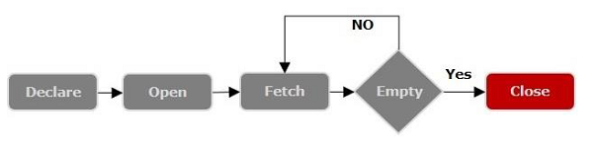

**Problem- 1**

Write a Cursor program using MySQL to retrieve the email-ids (build an email list) of employees from employees table.

**SOLUTION :**

create table employees(id integer, Name varchar(100), email varchar(100));

insert into employees(id, Name, email) values(1, "Harry Potter", "pharry@warnerbros.com");

insert into employees(id, Name, email) values(2, "Clark Kent", "kclark@dccomics.com");

insert into employees(id, Name, email) values(3, "Tony Stark", "stony@marvel.com");

DELIMITER $$

CREATE PROCEDURE build_email_list (INOUT email_list varchar(4000))

BEGIN

DECLARE v_finished INTEGER DEFAULT 0;

DECLARE v_email varchar(100) DEFAULT "";

-- declare cursor for employee email

DECLARE **email_cursor** CURSOR FOR

**SELECT email FROM employees;**

-- declare NOT FOUND handler

DECLARE CONTINUE HANDLER FOR

**NOT FOUND** SET v_finished = 1;

OPEN email_cursor;

get_email: LOOP

FETCH email_cursor INTO v_email;

IF v_finished = 1 THEN

LEAVE get_email;

END IF;

-- build email list

SET email_list = CONCAT(v_email,";",email_list);

END LOOP get_email;

CLOSE email_cursor;

END $$

DELIMITER ;

-- Calling the procedure and getting the email list

SET @email_list = "";

CALL build_email_list(@email_list);

SELECT @email_list;

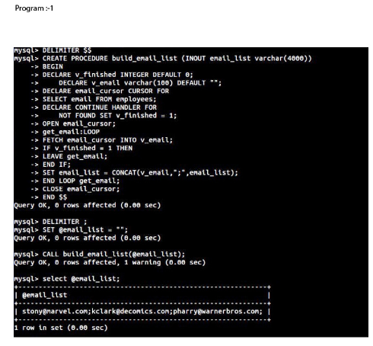

**RESULT:**

Thus the Cursor program using MySQL is executed successfully.